We utilized the zipfR package to perform frequency analysis on the top 10 documents identified from the corpus top10Corp. To do so a for loop passes each of the individual documents from top10Corp per iteration to the zipf_work(document) function which accepts a corpus’ document.

Within the zipf_work() function each documents terms are split into a character vector of document terms. This vector of terms is then passed to the text2spc file to create a frequency spectrum object. Frequency spectrum objects contain the distribution of terms across frequency classes. These frequencies are plotted in the three different formats below.

With the documents term frequencies represented in within a frequency object we then plot a histogram of its frequency classes.

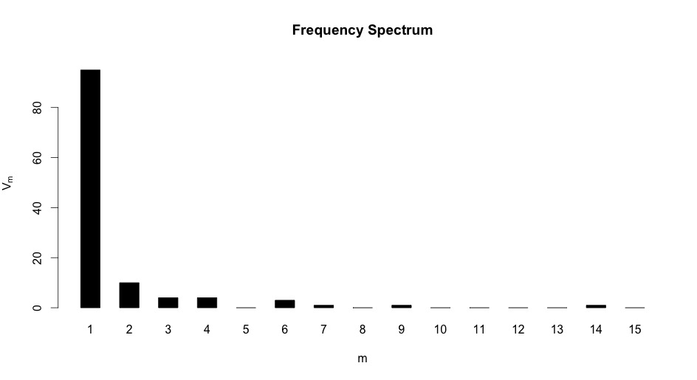

We additionally can extend the m axis from 15 frequency classes to 50 to show a broader distribution as shown below.

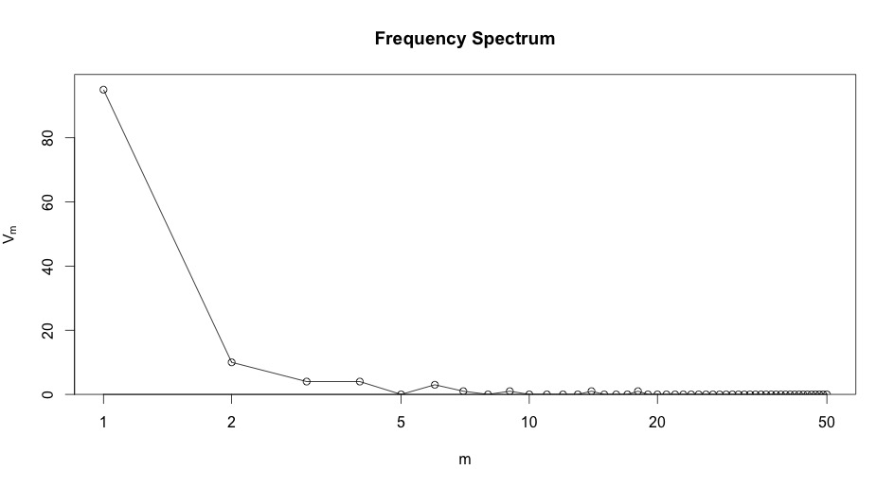

A final cluster plot representation of the distribution is depicted below.

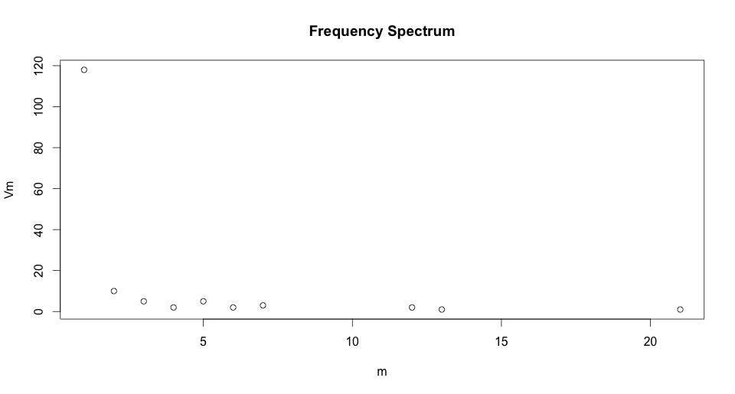

After plotting the term frequencies for each of the top 10 documents when then provide a plot of term frequency by ranking if the frequency classes present in the corpus.